- Copy Folder KMPortal To Drive : C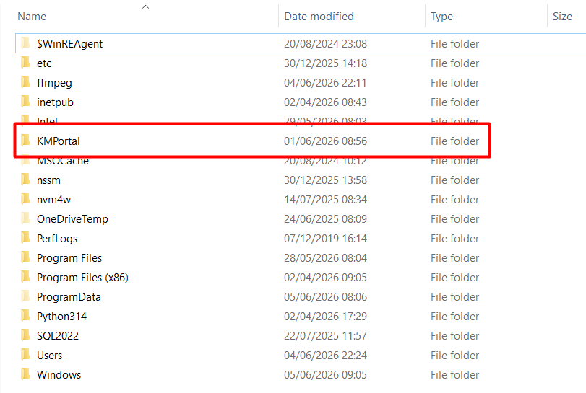
- Run kmportal-protocol.reg On Login : Administrator or Permission User is Administrator

